7
JavaScript Beyond the Browser
Originally JavaScript was designed as a client-side scripting language, but today it is used literally everywhere: in server scripting, mobile and desktop software programming, game development, DB querying, hardware control and OS automation. When you have experience in client-side JavaScript, with a little of addition knowledge, you can apply your skills in other programming areas. Here we will learn how to write a command-line tool, a web-server, a desktop application and mobile software by using JavaScript.
In this chapter we will be learning about:
- Level up coding a command-line program in JavaScript
- Building a web-server with JavaScript
- Writing a desktop HTML5 application now easier!
- Using PhoneGap to make a mobile native app

Level up coding a command-line program in JavaScript
You must have heard about Node.js, That’s an open source cross-platform development environment allowing creation of web-servers, networking and other tools by using JavaScript. Node.js extends classical JavaScript with a collection of specialized modules. These modules handle file system I/O, networking, OS-level operations, binary data, cryptography functions, data streams and other (https://nodejs.org/api/index.html). Node.js uses an event-driven I/O model. Alike JavaScript, it operates on single thread performing non-blocking calls. So time-consuming functions can run concurrently invoking a callback when it completes.
To get the feel of Node.js, we start with an example that simply prints “Hello world”:
hello.js
console.log( "Hello world!" );

Now let’s open the console (command-line interface: CMD in Windows, Terminal in Linux and MacOS), navigate to the example script location and run:
node hello.js
Here we go, we get “Hello world!” in the output.

Windows CMD
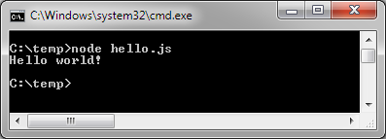
Insert image B04886_07_06.png
Node.js modules follow CommonJS specification in the way we examined in Chapter 2: Modular programming with JavaScript:
foo.js
console.log( "Running foo.js" );
module.exports = “foo”;
main.js
var foo = require( "./foo" );
console.log( "Running main.js" );
console.log( "Exported value:", foo );

As we run main.js we are supposed to get the following output:
Running foo.js
Running main.js
Exported value: foo
Node.js native modules such as “fs” (https://nodejs.org/api/index.html) don’t require downloading. We may just refer them in require() and the run-time will know where to find them
"use strict";
var fs = require( "fs" );
fs.readFile( __filename, "UTF-8", function( err, data ){
if ( err ) {
throw new Error( err );
}
console.log( "Source of ", __filename, ":\n", data );
});
Here we use File System I/O (fs) module to read a file. __filename property of a module scope contains the absolute path of the executing source file. Remember the Error First Callback approach that we examined in Chapter 5: Asynchronous JavaScript? That is the main interface for asynchronous functions in Node.js.
Let’s try now something more practical. We’ll write a utility that scans recursively all the sources files in a given directory to make sure every file has in block comments up-to-date copyright. First of all, we need a module that can test if a supplied block comment text contains actual copyright line:
./Lib/BlockComment.js
/**
* Block comment entity
* @class
* @param {String} code
*/
var BlockComment = function( code ){
return {
/**
* Check a block comment
* @returns {Boolean}
*/
isValid: function(){
var lines = code.split( "\n" );
return lines.some(function( line ){
var date = new Date();
return line.indexOf( "@copyright " + date.getFullYear() ) !== -1;
});
}
};
};

module.exports = BlockComment;

Here we have a constructor that creates an object representing the BlockComment. The object has a method (isValid) to test its validity. So if we create an instance of BlockComment with a block comment text we can validate it against our requirements:
var comment = new BlockComment( "/**\n* @copyright 2015 \n*/" );
comment.isValid() // true

Now we write a module capable to test if all the copyright lines in a given source code have the actual year:
./Lib/SourceFile.js
/** @type {module:esprima} */
var esprima = require( "esprima" ),

/**
* Source file entity
* @class
* @param {String} fileSrc
* @param {module:Lib/BlockComment} BlockComment - dependency injection
*/
SourceFile = function( fileSrc, BlockComment ){
return {
/**
* Test if source file has valid copyright
*/
isValid: function() {
var blockComments = this.parse( fileSrc );
return Boolean( blockComments.filter(function( comment ){
return comment.isValid();
}).length );
},
/**
* Extract all the block comments as array of BlockComment instances
* @param {String} src
* @returns {Array} - collection of BlockComment
*/
parse: function( src ){
return esprima.parse( src, {
comment: true
}).comments.filter(function( item ){
return item.type === "Block";
}).map(function( item ){
return new BlockComment( item.value );
});
}

};
};

module.exports = SourceFile;
In this example we introduce a SourceFile object that have two methods parse and isValid. Private method parse extracts all the block comments from a given JavaScript source code and returns an array of BlockComment objects. Method isValid checks if all of the received BlockComment meet our requirements. In these methods to manipulate arrays we use Array.prototype.filter and Array.prototype.map that we have examined in the Chapter 1: Diving into JavaScript core.
But how can we reliably extract block comments from a JavaScript source? The best way is to go with a bulletproof solution called Esprima parser (http://esprima.org/) that performs code static analysis and returns full syntax tree including comments. However esprima is a 3rd-party package, that is supposed to be downloaded and linked from the application. In general, a package may depend on other packages, that also have dependencies. It looks like bringing required dependencies all together may be a hell of work. Fortunately Node.js is distributed with NPM package manager. The tool can be used to install and manage registered in NPM repository (https://www.npmjs.com/) 3rd party modules. NPM doesn’t just download requested modules, but resolve the module dependencies, allowing a well-grained structure of reusable components in the scope of a project or in the global scope.
So, to make esprima available in our application we simply request it from NPM: npm install esprima
By running this command in the console we automatically get a new subdirectory node_modules with the esprima package in it. If package requires any dependencies they will be fetched and allocated in node_modules respectively. As soon as package installed by NPM, Node.js can find it by its name e.g. require( "esprima" )Now when we have SourceFile object, we just need the main script that will read the files from a given directory and tests them with SourceFile:
copyright-checker.js
/** @type {module:cli-color} */
var clc = require( "cli-color" ),
/** @type {module:fs-walk} */
walk = require( "fs-walk" ),
/** @type {module:path} */
path = require( "path" ),
/** @type {module:fs} */
fs = require( "fs" ),
/**
* Source file entity
* @type {module:Lib/SourceFile}
*/
SourceFile = require( "./Lib/SourceFile" ),
/** @type {module:Lib/BlockComment} */
BlockComment = require( "./Lib/BlockComment" ),
/**
* Command-line first argument (if none given, go with ".")
* @type {String}
*/
dir = process.argv[ 2 ] || ".";

console.log( "Checking in " + clc.yellow( dir ) );

// Traverse directory tree recursively beginning from 'dir'
walk.files( dir, function( basedir, filename ) {
/** @type {Function} */
var next = arguments[ 3 ],
/** @type {String} */
fpath = path.join( basedir, filename ),
/** @type {String} */
fileSrc = fs.readFileSync( fpath, "UTF-8" ),
/**
* Get entity associated with the file located in fpath
* @type {SourceFile}
*/
file = new SourceFile( fileSrc, BlockComment );
// ignore non-js files
if ( !filename.match( /\.js$/i ) ) {
return next();
}
if ( file.isValid() ) {
console.log( fpath + ": " + clc.green( "valid" ) );
} else {
console.log( fpath + ": " + clc.red( "invalid" ) );
}
next();
}, function( err ) {
err && console.log( err );
});

In this code we rely on 3rd party module cli-color to colorize command-line output. We use fs-walk module to traverse recursively through a directory. And Node.js native module path allows us to resolve the absolute path by given relative directory and filename and fs built-in module we use to a read a file.
As we intend to run our application from the console we can use command-line options to pass on a directory that we want to test:

node copyright-checker.js some-dir
Script arguments we can extract from build-in object process(process.argv). For this command process.argv will contain an array like:
[ “node”, “/AbsolutePath/copyright-checker.js”, “some-dir” ]

So in the main script now we can pass the third element of this array to walk.files. The function will traverse through the given directory and run the callback for every found file. In the callback function if a filename looks like JavaScript we read the content and test if by using SourceFile object.
Before we can run the main script, we need to ask NPM for 3rd party packages that we use in it:
npm install fs-walk cli-color

Now we are good to go. As we run `node copyright-checker.js fixtures` we get a report on validity of the JavaScript files located in `fixtures`:

MacOS Terminal
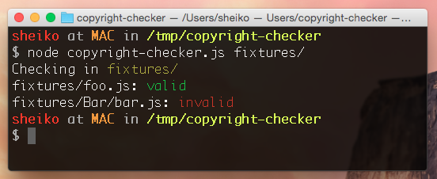
Insert image B04886_07_01.png

Building a web-server with JavaScript
We’ve just learnt how to write command-line scripts with Node.js. However this run-time is mostly known as server-side JavaScript meaning software to run an HTTP-server. To say truth Node.js is especially great for this kind of job. If we launch a server application based on Node.js it runs permanently, initialized only once. For an instance we may create a single DB connection object and reuse it whenever someone requests the application. Besides it grants us with all the flexibility and power of JavaScript including event-driven, non-blocking I/O.
So how can we make use of it? Thanks to HTTP native module of Node.js a simple web-server can be implemented as easy as that:
simple-server.js
"use strict";
/** @type {module:http} */
var http = require( "http" ),
/** @type {HttpServer} */
server = http.createServer(function( request, response ) {
response.writeHead( 200, {"Content-Type": "text/html"} );
response.write( "<h1>Requested: " + request.url + "</h1>" );
response.end();
});

server.listen( 80 );
console.log( "Server is listening..." );

Here we create a server with a dispatcher callback to handle HTTP requests. Then we make the server listening port 80. Now run from the console `node simple-server.js` and then hit http://localhost in a browser we are expected to see
Requested: /
So to make a simple static web server we just need to route incoming requests, read the corresponding HTML files and send them with the response. Or we can install existing modules connect and serve-static:
npm install connect serve-static
And implement the server that concise:
"use strict";
/** @type {module:connect} */
var connect = require( "connect" ),
/** @type {module:serve-static} */
serveStatic = require( "serve-static" );

connect().use( serveStatic( __dirname ) ).listen( 80 );

In practice routing requests can be a challenging task, so we rather go with a framework e.g. Express.js (http://expressjs.com). Then our routing may look like that:
"use strict";
/** @type {module:express} */
var express = require( "express" ),
/** @type {module:http} */
http = require( "http" ),
/** @type {Object} */
app = express();
// Send common HTTP header for every incoming request
app.all( "*", function( request, response, next ) {
response.writeHead( 200, { "Content-Type": "text/plain" } );
next();
});
// Say hello for the landing page
app.get( "/", function( request, response ) {
response.end( "Welcome to the homepage!" );
});
// Show use if for requests like http://localhost/user/1
app.get( "/user/:id", function( request, response ) {
response.end( "Requested ID: " + req.params.id );
});
// Show `Page not found` for any other requests
app.get( "*", function( request, response ) {
response.end( "Opps... Page not found!" );
});

http.createServer( app ).listen( 80 );

Writing a desktop HTML5 application now easier!
Have you ever wondered of writing desktop application with HTML5 and JavaScript? Nowadays we can do it quite easy with NW.js. This project is a cross-platform application runtime based on Chromium and Node.js. So it provides a frameless browser where both the DOM API and Node.js API available. In other words, we can run in NW.js classical web-applications, access low level APIs (file system, network, processes and so on) and reuse modules of NPM repository. Interesting? We’ll start a tutorial where we create a simple HTML5 application and run it with NW.js. It’ll be a roster application with a form to enter names and a list of already submitted ones. The names will be stored in localStorage. Let’s rock it.

Setting up the project
First of all we have to download from http://nwjs.io NW.js run-time relevant to our platform (MacOS, Windows, Linux). Next to the NW.js executable (nw.exe, new.app or nw depending on the platform) we place package,json file (https://github.com/nwjs/nw.js/wiki/manifest-format) where we describe our project:
{
"name": "roster",
"main": "wwwroot/index.html",
"window": {
"title": "The Roster",
"icon": "wwwroot/roaster.png",
"position": "center",
"resizable": false,
"toolbar": false,
"frame": false,
"focus": true,
"width": 800,
"height": 600,
"transparent": true
}
}
Our package.json file has three main fields. ‘Name’ contains a unique name associated with project. Note that this value will be a part of the directory path where application data (sessionStorage, localStorage, and so on) is stored. ‘Main’ accepts relative path to the main HTML page of the project. Eventually ‘window’ describes the browser window where display the HTML.

Adding HTML5 application
According to main field in package.json we place our index.html into wwwroot subdirectory. We can try it with a simple HTML like:
<html>
<body>
Hello world!
</body>
</html>
NW.js treats the HTML the very same way as a browser, so if we launch now NW.js executable we will see ` Hello world!`. If we add CSS and JavaScript we will give it some welly. So we can write the code for NW.js the way we do it for a browser. And here we have a good opportunity to apply the principles we learnt in Chapter 6: Large-Scale JavaScript Application Architecture. In order to make the example concise but expressive we will take AngularJS approach. First we create the HTML. The markup the body may look like that:
<main class="container">
<form >
<div class="form-group">
<label for="name">Name</label>
<input class="form-control">
</div>
<button class="btn btn-danger">Empty List</button>
<button type="submit" class="btn btn-primary">Submit</button>
</form>
<table class="table table-condensed">
<tr>
<td></td>
</tr>
</table>
</main>
We define a form to submit new names and a table to display already stored ones. To make it prettier we use here Bootstrap (http://getbootstrap.com) styles. The CSS file can be loaded from a CDN:
<link rel="stylesheet" href="https://maxcdn.bootstrapcdn.com/bootstrap/3.3.5/css/bootstrap.min.css">
Now to bring it to life by adding AngularJS directives:
<html>
<body ng-app="myApp" >
<main ng-controller="RosterController" class="container">
<form ng-submit="submit()">
<div class="form-group">
<label for="name">Name</label>
<input class="form-control" id="name" name="name" ng-model="name" required placeholder="Name">
</div>
<button ng-click="empty()" class="btn btn-danger">Empty List</button>
<button type="submit" class="btn btn-primary">Submit</button>
</form>
<table class="table table-condensed">
<tr ng-repeat="person in persons">
<td>{{person.value}}</td>
</tr>
</table>
</main>
</body>
</html>
Here we declare a module scope myApp (`<body ng-app="myApp" >`). Within it we define a controller RosterController. In the boundaries of the controller we bind out input field to model name (`<input ng-model="name">`) and set handlers for form submit and Empty List button click events (`<form ng-submit="submit()">` and ` <button ng-click="empty()"> `). Lastly we make of the table a template bound to $scope.persons collection. So whenever the collection changes the table is updated:
<table class="table table-condensed">
<tr ng-repeat="person in persons">
<td>{{person.value}}</td>
</tr>
</table>
Now it the time to add some JavaScript to our HTML:
<script>
var app = angular.module( "myApp", [ "ngStorage" ]);

app.controller("RosterController", function( $scope, $localStorage ) {
var sync = function() {
$scope.persons = JSON.parse( $localStorage.persons || "[]" );
};
sync();
$scope.name = "";
$scope.submit = function() {
sync();
$scope.persons.push({ value: $scope.name });
$localStorage.persons = JSON.stringify( $scope.persons );
};
$scope.empty = function() {
$localStorage.persons = "[]";
sync();
};
});
</script>
As we intend to store the data submitted in the form, we can use localStorage that we discussed in Chapter 4: HTML5 APIs. In order to get localStorage the AngularJS way we use ngStorage module (https://github.com/gsklee/ngStorage). So we specify the plugin during module initialization and it makes it available in the controller as a parameter ($localStorage). In the controller body we have a function sync that set $scope.persons with the person array from localStorage. We call this sync function in form submit handler ($scope.submit) and in Empty List button on-click handler ($scope.empty). It causes every time the person table to update. During handling submit event we append the value of the input $scope.persons and save $scope.persons in localStorage.
In order to enable this functionality we have to load the AngularJS and ngStorage plugin:
<script src="http://ajax.googleapis.com/ajax/libs/angularjs/1.3.14/angular.min.js"></script>

<script src="https://cdnjs.cloudflare.com/ajax/libs/ngStorage/0.3.6/ngStorage.min.js"></script>
Now we launch NW.js executable and get the application working.
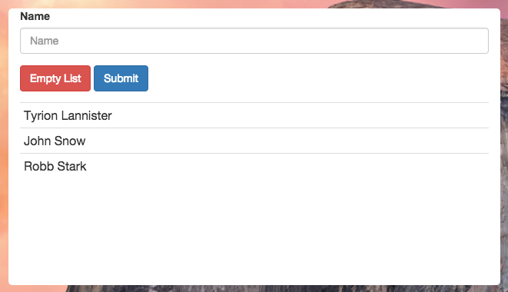Insert image B04886_07_02.png
It’s all nice, but as we run NW.js frameless we have even no way to close the application. Besides, we cannot drag the application window within the desktop. That’s easy to fix. We can add to the HTML body an HTML fragment with two buttons to close and to minimize the application.
<header ng-controller="ToolbarController">
<a href="#" ng-click="minimize()">Minimize</a>
<a href="#" ng-click="close()">Close</a>
</header>

Now we subscribe listeners to these buttons that call NW.js Window API (https://github.com/nwjs/nw.js/wiki/Window) methods respectively close and minimize.
var win = require( "nw.gui" ).Window.get();
app.controller("ToolbarController", function( $scope ) {
$scope.close = function(){
win.close();
};
$scope.minimize = function(){
win.minimize();
};
});
In order to make our window draggable (https://github.com/nwjs/nw.js/wiki/Frameless-window) we can use CSS pseudo-class -webkit-app-region. We set it with drag value on the handle container (header) and with value no-drag on any clickable elements within it:
header {
-webkit-app-region: drag;
}
header a {
-webkit-app-region: no-drag;
}
In addition, we prettify the look & feel of the page. Note that with NW.js we can have a transparent background. So if we set border-radius on html element and the window itself gets rounded.
html {
height: 100%;
border-radius: 20px;
background-color: rgba(0,0,0,0);
}
body {
min-height: 100%;
background: linear-gradient(to bottom, #deefff 0%,#98bede 100%);
overflow: auto;
}
header {
text-align: right;
width: auto;
padding: 12px;
background: rgba(255,255,255, 0.5);
border-radius: 20px 20px 0 0;
-webkit-app-region: drag;
}
header a {
margin: 12px;
-webkit-app-region: no-drag;
}

Now we can launch our NW.js executable again.
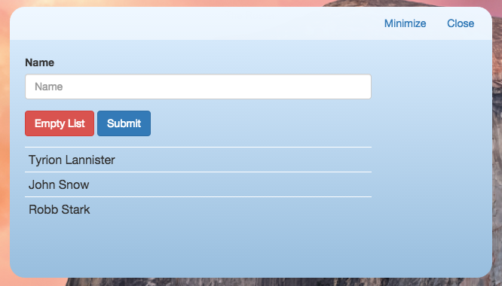
Insert image B04886_07_03.png
Note that on MacOS/Linux to get the transparency we have to launch with special arguments (https://github.com/nwjs/nw.js/wiki/Transparency). E.g. on MacOS:
open -n ./nwjs.app --args --enable-transparent-visuals –disable-gpu

Debugging
Still something is missing. If anything goes wrong how can we debug and trace the errors? There are available a few options:
- Launch NW.js executable with --enable-logging argument and get the logs in stdout.
- Launch NW.js executable with --remote-debugging-port and access application DevTools in a remotely running Chrome. For an instance we start up the project as `nw --remote-debugging-port=9222` and look for http://localhost:9222 page in Chrome.
- Enable toolbar and frame for the window in package.json
The first option isn’t quite handy in debugging. The second provides you with a limited version of DevTools and the last option brings the frame and can make the application looking terrible. Fortunately we can call DevTools programmatically from the app. So on DEVELOPMENT/TEST environment you can add this code that shows up DevTools by pressing Ctrl-Shift-I.
console.info( "Here we go!" );

document.addEventListener( "keydown", function( e ){
var key = parseInt( e.key || e.keyCode, 10 );
// Ctrl-Shift-i
if ( e.ctrlKey && e.shiftKey && key === 73 ) {
e.preventDefault();
win.showDevTools();
}
}, false );
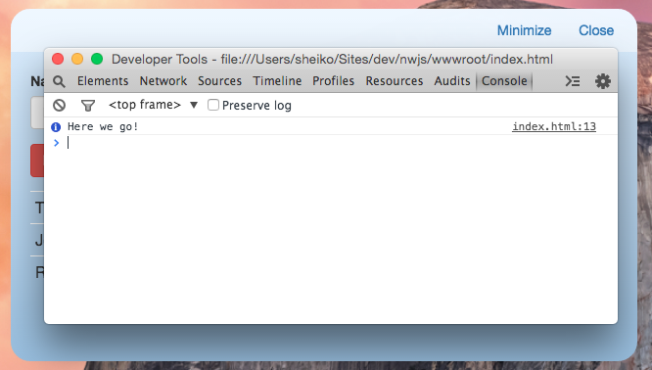
Insert image B04886_07_04.png

Packaging
To have a real desktop application experience and we can bundle the projects assets and NW.js files into a single executable. Firstly we compress using ZIP our project directory (wwwroot) and accompanying files (node_modules directory, NAPI plugins) into app.nw. Then we combine the archive with NW.js executable. In Windows it can be done like so:
run copy /b nw.exe+app.nw app.exe

If the distribution of NW.js targeted for you platform contains any components (e.g. Windows distribution includes DLLs) inject them into the newly created application executable by using Enigma Virtual Box (http://enigmaprotector.com). Voilà, now we can distribute the project in a single file.

Using PhoneGap to make a mobile native app
Well, now we can make desktop applications with JavaScript, but what about native mobile applications? There is a number of web-based frameworks for mobile development available https://en.wikipedia.org/wiki/Multiple_phone_web-based_application_framework. One of the most trending solutions is called Adobe PhoneGap, which is built on top of Apache Cordova project. By and large PhoneGap application consist of web-stack (HTML5, CSS, and JavaScript). Despite the fact that nowadays HTML5 provides access to some of native features (accelerometer, camera, contacts, vibration, GPS, and others), the support across the different devices is inconsistent and quirky, performance is relatively poor. So PhoneGap runs the HTML5 inside a native WebView on a device and provides access to device resources and API (https://en.wikipedia.org/wiki/Foreign_function_interface). As a result we can write once a mobile application based on HTML5 and build it with PhoneGap for the devices and OS’ that we support (iPhone, Android, Blackberry, Windows, Ubuntu, Firefox OS and others). A good point here that we can reuse components created for web while developing for mobile. In point of fact we can bundle the Roster application that we made for NW.js as a mobile app. So let’s do it.

Setting up the project
First of all we need we need the framework. The easiest way to install it by using NPM tool:
npm install -g cordova
The option -g means we install it globally on the machine and don’t need to do it when setting up any new project.
Now we can create a new project with the following command:
cordova create roster org.tempuri.roster Roster
The tool creates in the subdirectory roster a boilerplate file structure for the project named Roster registered within org.tempuri.roster namespace.
Now we need to inform PhoneGap what platforms we want to support. So we navigate to roster subdirectory and type following:
cordova platform add ios
cordova platform add android

Building the project
In the subdirectory www we can find placeholder HTML5 application. We can replace it with the roster application written for NW.js (without environment-specific header container and its listeners code of course). In order to check if the project was properly initialized we run:
cordova build ios
cordova emulate ios
or
cordova build android
cordova emulate android
This builds the project and show it with platform-specific emulator. On a Mac looks so:
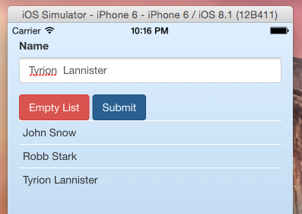
Insert image B04886_07_05.png

Adding plugins
As it said already with PhoneGap we can access native device features (http://phonegap.com/about/feature). Moreover we also can install and use native plugins available aplenty in Cordova repository (http://plugins.cordova.io/npm/index.html). Let’s take one of there - cordova-plugin-vibration. We can add it to the project as easy as it:
cordova plugin add cordova-plugin-vibration

As we have the plugin we can use its API in our JavaScript code:
// Vibrate for 3 seconds
navigator.vibrate(3000);

Debugging
As for debugging mobile application there is a number of options (https://github.com/phonegap/phonegap/wiki/Debugging-in-PhoneGap). The main idea is to reach the application with a desktop inspector tool. In the case of iOS we go with desktop Safari WebInspector. Just find the “iPhone Simulator” option in “Develop” menu and press WebView corresponding your application HTML. Similarly we can access Android WebView in Chrome DevTools (https://developer.chrome.com/devtools/docs/remote-debugging#debugging-webviews).

Summary
Widely spread Node.js run-time extends JavaScript with low-level API, what unlocks us on creating command-line tools, web-servers and specialized servers (e.g. UDP-TCP/WebSocket/SSE servers). To see how far we can go beyond the Web just consider a stand-alone OS NodeOS built with Node.js. With HTML5 and JavaScript we can write desktop software and easily distribute across different platforms. Similarly we can compose mobile application out of HTML5/JavaScript and native APIs. By using tools like PhoneGap we can build the application for diverse mobile platforms.
In this chapter we’ve learnt how to access Dev.Tools for debugging NW.js and PhoneGap applications. In the next chapter we will talk about how to use the DevTools efficiently.

